Endowments and New Institutions for Long-term Observations:

BY D. JAMES BAKER, RAY SCHMITT, CARL WUNSCH

(Original version submitted to Oceanography 28 July 2007, final version submitted 2 November 2007)

Introduction

An ever increasing volume of publications on the changing ocean environment underscores the requirement for long-term observations for the understanding and prediction of ocean and climate change. These observations have to be globally distributed and carried out over long periods of time. But a means of obtaining those observations – particularly in the ocean - is not in place today. There is no global system of routinely funded long-term, high quality measurements to provide the necessary understanding of climate in general and the ocean in particular. The scientific literature is full of examples of tantalizing short records that do not illuminate the physical problems. Long-term biological measurements are in an even more limited state of development. Now with society demanding better forecasts, and the need to quantify the human role in climate change, it is more important than ever that we find the ways to establish the necessary institutional basis and achieve the proper levels of funding for long-term measurements.

Because of the large sums involved, government resources must remain the basis for funding satellites and in-situ instruments, their deployment, and the associated data systems. But governments have been slow to respond to the needs. Today, less than half of an initial global system is being funded, and most of that is coming from research funding. How can we convince governments to maintain a system of long-term measurements in an operational mode, where properly calibrated observations are supported on a routine basis for the indefinite future? New modes of funding in addition to continuing and enhanced government support, and most probably involving large endowments, can help to stimulate government funding, can help keep these measurements going and can add to the support of the associated science and technology development. To make this happen, new thinking about institutions and funding for long-term observations is required and here we outline some possible directions. Our ideas are based on discussions that we have had with ocean scientists and representatives from government funding agencies, industry, and international bodies that are all grappling in different ways with the problems of observing the oceans and climate.

Today’s records are too short for understanding Earth’s climate

It is a truism of science that to understand a phenomenon one must observe it. What we perceive today as climate change is the summation of variations on time scales ranging from the age of the Earth, circa 3.5 billion years, to interannual fluctuations. This summation is a major problem in understanding climate change today, because one must be able to separate the differing time scales. To the extent that climate variability occurs on some time scale, T, and has a stochastic component to it, one must observe it over many multiples of T. Thus a scientist trying to understand ocean surface waves is unlikely to agree that observing one wave over one wave period would be sufficient for understanding of the physics of such waves.

To understand what is going on over the time scales of immediate interest to human society (somewhat arbitrarily chosen to be decades to hundreds of years), one needs observations, minimally, over those same time scales. In practice, the instrumental record useful for understanding climate change is woefully short.

Much of what we know about the climate system comes from the rare long time series of meteorological data extending back about 350 years. The longest instrumental atmospheric record appears to be the central England temperature composite which began in 1659 (Manley, 1975). Many of these early long records originated when a lone individual started making daily weather observations, perhaps to aid the management of a farm, but sometimes out of scientific curiosity. The dutiful logging of meteorological data was a long tradition amongst farmers and sailors; Thomas Jefferson and George Washington kept their own measurements to guide their plantings; Benjamin Franklin kept his as a student of weather. While these statesmen had their own reasons for recording the data, no doubt there was a sense of responsibility for posterity; an intuition that someone would someday make sense of the weather. Indeed, the first coherent view of ocean currents was assembled from numerous ship logs by Matthew Fontaine Maury. Clearly, both data collector and data analyst are necessary for progress.

Nearly all environmental records are much shorter than those for air temperature at a few sites. Truly useful global atmospheric observations began only after World War II. Global ocean observations with near-adequate coverage began after 1990, and accurate measurements of glacial ice volume which require satellite coverage began little more than five years ago. The global sea level rise record is accurate only in the satellite altimetry era of about 15 years duration, and sea surface temperature records are accurate only in the satellite age, about 30 years; significant information about the changing ocean at depth is only now becoming available. Similar issues plague the wider problems of climate change on land, but we focus here on the ocean, as a clear example of the wider problem.

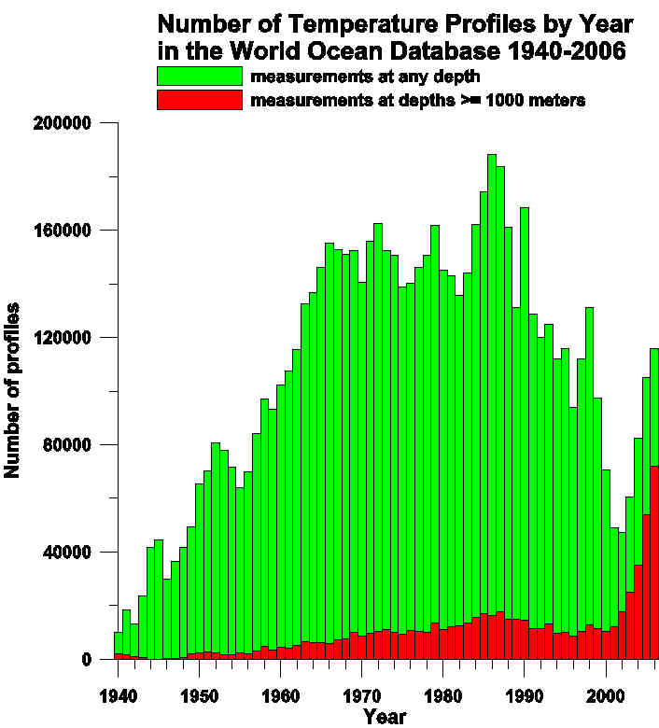
Figure 1. Number of temperature profiles entered per year in the World Ocean Database. The total peaked in 1986, but the decrease in Naval deployment of XBTs caused a steep decline in the following decades. Since the turn of the century, the ARGO float program has helped to reverse the downward trend. (Source: Tim Boyer, NODC)

The extremely limited observational record is probably the major obstacle to understanding global change as it is taking place today. Short instrumental records have driven scientists to exploring the so-called paleo-record – essentially the geological and geochemical signatures of climate change as recorded in the sea floor, in ice, and as preserved in the rock record. Interesting and useful as these are, paleo-records are limited in coverage in space and time, and are always laden with serious questions of interpretation. The alternative has been the use of numerical models, some now quite sophisticated but many questions linger about their sub-grid-scale parameterizations. In the absence of adequate data to test them, they remain of uncertain skill.

What is to be done? The scientific community must continue to explore the construction and utility of better climate models, and work to greatly extend the paleoclimate data base. But these, whatever their promise, are unlikely ever to be an adequate substitute for good instrumental records. If one looks to the future, to our successors over coming generations, we need as a society to extend the instrumental record indefinitely into the future. Those coming generations will require instrumental records spanning decades and centuries. Can such extended records be achieved?

Obstacles to long-term time series

Significant challenges loom in the collection of open ocean data of any kind. Since the cessation of the limited weather ship records in the 1970s, only a handful of oceanic time series have survived. These are proving invaluable in documenting the nature and magnitude of oceanic variability in a handful of possibly representative locations. Yet most ocean time series are maintained by a fragile, patchwork funding scheme in increments of 3-5 years. The toll on those committed individuals who try to maintain such sampling programs is considerable.

It has always been difficult for governments to sustain measurement programs over years and decades. Even weather observations are under threat from competing interests. The number of radiosonde profiles collected each year peaked in 1988 as did ocean temperature profiles in 1986 (Figure 1). The World Meteorological Organization still struggles to establish a Global Climate Observing System. International funding for the global array of Argo floats appears to have plateaued. In the U.S., we still do not see long-term commitments for the Integrated Ocean Observing System. NASA has downgraded the priority of Earth remote sensing, and NOAA has not been able to find funding for continuation of critical operational altimeter and scatterometer satellites. In Europe the good news of commitment to a Global Monitoring for Environmental Security program of both in-situ and satellite systems is counterbalanced by the bad news of a continual push for meteorological agencies to charge for data, which largely defeats the purpose of free and open data exchange.

In short, we are facing the uncomfortable prospect of knowing less about our environment than we did a few years ago---just as the world enters new regimes of CO2, methane, aerosol, and other forcings. Given the short time horizon of the political process, one has to question whether governments can in fact, without substantial new commitments, meet the new long-term responsibilities of collecting useful ocean, or more generally, climate, data. We believe that the new institutions discussed below could go a long way towards convincing governments to make the necessary new commitments.

Any oceanographer who has attempted to sustain long-duration measurements for scientific use usually comes up against numerous practical obstacles: (1) Such measurements need to become essentially routine and hence removed from the quality control of those who use the data for research. (2) All technologies become obsolescent, and have to be replaced. The design of instruments, their testing, construction, calibration and deployment for use over decades requires different skills and funding support from the usual research efforts. (3) Long records are typically worth reanalyzing when they double in length. A scientist with a 30 year record to work with has a long wait, and little personal incentive, to try and produce a record twice as long. (4) New scientific insights or technical developments can lead to difficult decisions to augment or entirely stop some measurements. (5) Funding cycles, government elections, times for academic promotion and tenure are all extremely short compared to time open-ended time scales required in understanding the climate system. A junior scientist is not well-advised to become involved with a program whose record will be interesting 20 years from now, and whose maintenance relies on grants that must be renewed every 3 years.

New institutions and funding for long-term data collection

What can one do? This problem is only partially a scientific and technical one—it is also one of sociology and politics. Few governments or government agencies willingly commit themselves to multi-decadal programs. (Some rare exceptions exist: the international weather network, sustained by acute national awareness of damage and loss of life from short-term weather; the nuclear fusion program, sustained by the national goal of cheap energy; and some space agency programs requiring a decade or more for development, construction and flight, among a very few others, driven by a national interest in maintaining cutting-edge space technology.) Given the long-term nature of the ocean and climate issues, and the year-to-year budget cycles and vicissitudes, it is difficult to imagine any government anywhere funding an open-ended observation system for oceans and climate in which the requisite scientific oversight and quality control would be present. In addition, few individuals are willing or able to take a long-view of their science, extending out decades and longer.

Is there a way to maintain that scientific oversight and quality control for data collection networks that would enhance and prove more reliable than government agency programs alone? These are data sets that, in general, we want to perpetuate indefinitely, as the scientific value increases greatly with the duration of the record. While we may not individually reap the benefits of long term records in our lifetime (though it is possible), they will certainly enhance the lives of our grandchildren and great-grandchildren.

An Endowed Institute for Climate Studies

One useful model to consider is the endowed institution. Many major universities have survived, a few for a millennium, by conservative management of endowments. Major science institutes have been established in the past by willing benefactors, particularly in medical sciences. Consider the establishment of an institute, probably not in a single location, appropriate for long-term ocean and climate studies. It would have to be privately endowed, to render it independent of any particular government funding source or governmental interests existing at a particular time. Such an institute could be thought of as a global college of wise men and women, dedicated to the goal of working together with government to sustain instrumental records of climate and ocean processes indefinitely. One would want them to be the best scientists, who were willing to take a long view. They would clearly need to sustain their scientific careers with other, shorter-range problems. How might one induce such a group to coalesce and to work toward a common goal, and to be self-renewing as the generations changed?

Suppose that one could gather about 50 such experts from around the world. Each, at mid-career, would be offered a “deal”: in exchange for (perhaps) 30% of their time, 50% of their salary would be paid, and they would be guaranteed support of one graduate student and one post-doc (or equivalent)—to do whatever the scientist wanted, not necessarily connected to the climate-change effort. In exchange, each such scientist would devote his or her 30% effort to sustaining a major element of the observation system – be it through continual lobbying for a new generation of satellites, the design of new instruments to measure trace gases, or the sustained calibration of in situ ocean instruments, or other useful activity. They would be unlikely to deploy such systems themselves, but would undertake to advise (and pressure) the appropriate governmental bodies. Collectively, they would function as a kind of senate, perhaps meeting once or twice a year to review the health of their enterprise. In conjunction with some executive committee, they would nominate younger, successor members. Perhaps the combination of a financial, professional, and multi-generational contribution would attract people to participate. One could imagine some kind of review of individual participation, about every 10-15 years.
An existing oceanographic institution might be persuaded to house the administrative component of such an institute and some of its individual scientists and engineers.

Funding for the Institute

How would the funding be established for such an effort? At present, the costs of doing research are growing while institutional funding for science is declining. This trend is unlikely to reverse anytime soon. Given other urgent national priorities, it is unlikely that new funds will be easily forthcoming for long-term operational measurements. Current U.S. funding for science is about 10% of the discretionary budget and has been at that level for 30 years (Science, 11 May 2007, p. 817). The last time that funding percentage was above 10% was during the Apollo program – a recognition of the decision to build a strong space program. We might anticipate that the U.S. government will continue to provide support at the existing level, with inflationary increases, but not more than that until there is an increased understanding of the risks to society from climate change and other sources. Thus we believe that new endowments are required.

What is the magnitude of such an endowment? Taking very round numbers, suppose each scientist required a salary contribution of $200,000/year with institutional overhead, and that the combination of a post-doc and student required another $150,000/year for a total for each scientist of $350,000/year. Fifty such individuals would then require $17.5 million dollars/year. If an endowment were assumed to return 5%/year, it would need to total $350 million to provide this income. One would probably double this value so that the endowment could outgrow inflation and it would be desirable to have some funding for exploratory instrumentation and ideas. Thus for an endowment of under $1 billion, one might make, over decades and even centuries, a serious contribution to the understanding of climate change in a way that no existing program can. This would provide strong leverage on the billions that are currently spent by government on observations alone. As a consequence, such an institute would help bring our government to the understanding of the need to make climate change a priority. A new institute, with people focusing on the observational and long-term issues of climate change, will help establish the need, and then maybe national spending priorities can change – as they did with the Apollo program.

The feasibility of raising $1 billion

The need is large: an endowment of $1 billion would be necessary to maintain a useful ocean observing system for climate. This may seem large, but in an age of multi-billionaires, is construction of such an organization and resources beyond reach?

We think it is not only feasible, but also fully in line with what is happening across the United States. For example, the Chronicle of Higher Education recently reported that more than 50 campuses across the United States have completed or are waging campaigns to raise $1 billion or more. Stanford University raised more than $900 million just in 2006. In an eight-day period from late May to early June of this year, four universities announced donations of at least $100 million each. Successful new businesses and rapidly growing economies across the world have produced much private wealth, and many of these donors want to build a better world. These examples show that a sufficiently justified fund-raising campaign for a $1 billion endowment would not be unreasonable.

The point is that we must do something new. In the past, major benefactors such as Andrew Carnegie, John D. Rockefeller, and Howard Hughes provided endowments for science institutions. More recently, the basic science community has benefited greatly from the Kavli Foundation’s network of institutes in the physical sciences (Science, 21 January 2005, p. 340). The example of mixing funding modes so successful in the medical sciences world should be followed.

Is there a billionaire amongst us who is capable of taking on the sort of personal responsibility displayed by the Carnegies and Rockefellers of the past? Could they provide the key support necessary for those who emulate Franklin and Maury in attempting to understand the world about them? It would make a truly extraordinary difference in our understanding of the climate system to have some key oceanic time series endowed in perpetuity. We look forward to further discussion and would welcome readers’ views on these issues.

References:
Manley, G. 1974: Central England Temperatures: monthly means 1659 to 1973. QJR Met. Soc, 100, 389-405.

D. JAMES BAKER (djamesbaker@comcast.net) is an oceanographer, former Administrator of the US National Oceanic and Atmospheric Administration and a Science and Management Consultant in Philadelphia,PA.
RAY SCHMITT (rschmitt@whoi.edu) is Senior Scientist, Department of Physical Oceanography, Woods Hole Oceanographic Institution, Woods Hole, MA.
CARL WUNSCH (cwunsch@mit.edu) is Cecil and Ida Green Professor of Physical Oceanography, Department of Earth, Atmospheric and Planetary Sciences, Massachusetts Institute of Technology, Cambridge, MA.

